Initial design of the proposed system and its user interface.

The initial design was produced and perfected using wireframe software which allowed for both the look and functionality of the proposed product to be modelled. A crisp white and blue colour scheme is used, disrupted by only the traffic light style marking system, this is in keep with the university logo that it’s PA forms are generated from. This wireframe software allowed the file to then generated within a web browser and worked through.

Generation of the wire frames was, as expected, an iterative process, with the main changes throughout the process being made not due to the design itself, but through the actual understanding of the steps a convenor would make, and what screens should be viewable from the beginning. Design decisions were made throughout though, with group opinions dictating the final version. Below is a step by step set of screens of what the software will be desired to resemble.

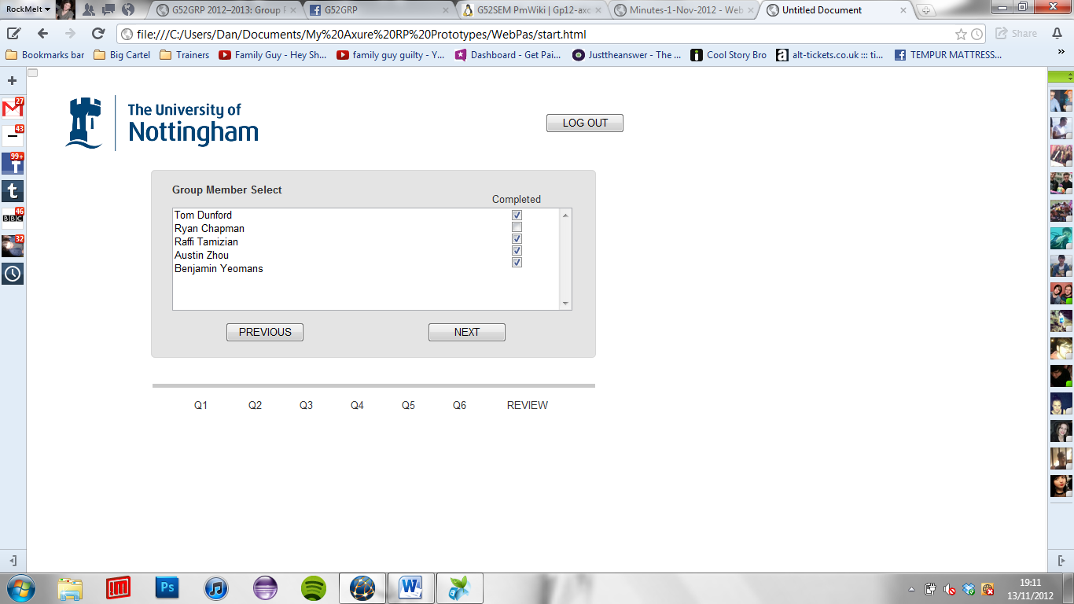

Above is the group member select screen, which follows the user sign in screen (which consists of the usual username and password entries) and module select screen which dictates which set of group members a student will be completing forms for. A completed tickbox is included here to clearly be able to tell which PA’s are left to be done.

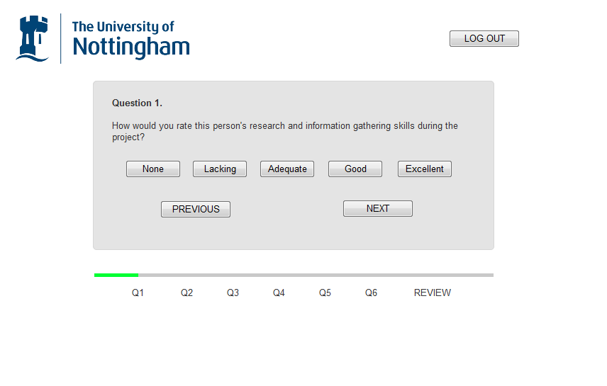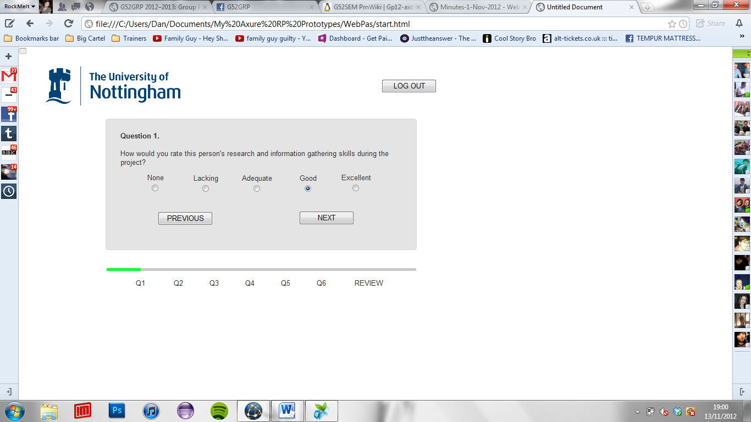

Iteration

Here is a typical entry form screen, with a 0-4 scaling system being used, for each question to be asked. The left image shows what was proposed initially, with it being decided that a radio button entry would be more logical and familiar. Below that is a process bar which shows the user how long they have left, aswell as dependent upon the colour the general rating that is being given within this PA.

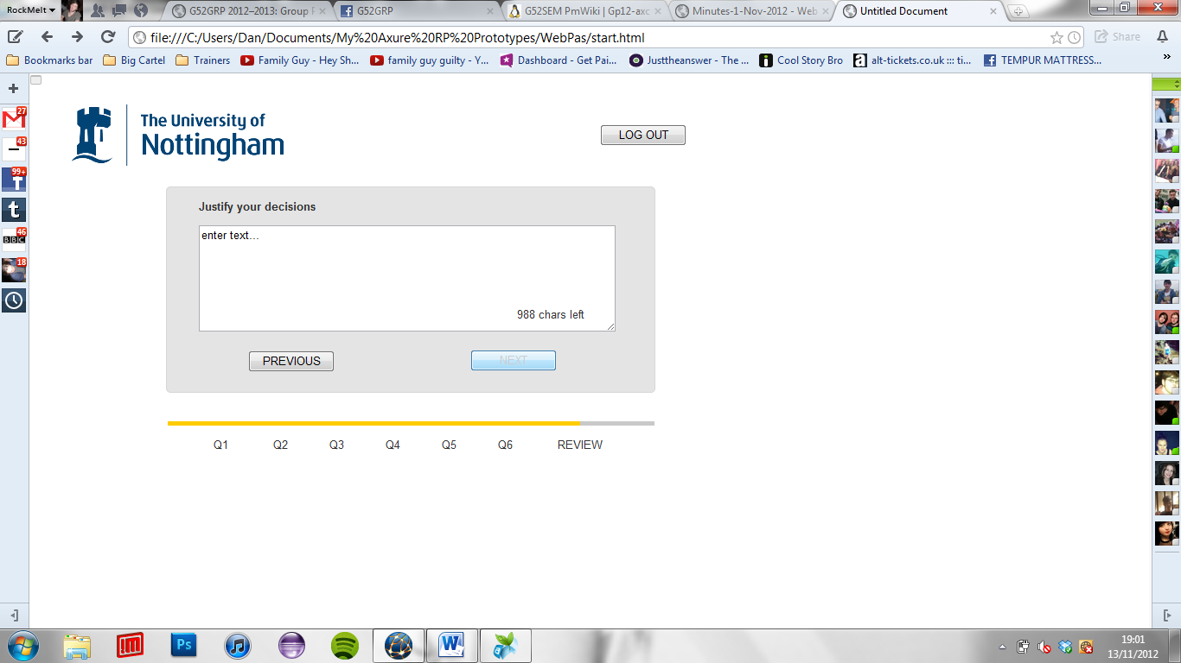

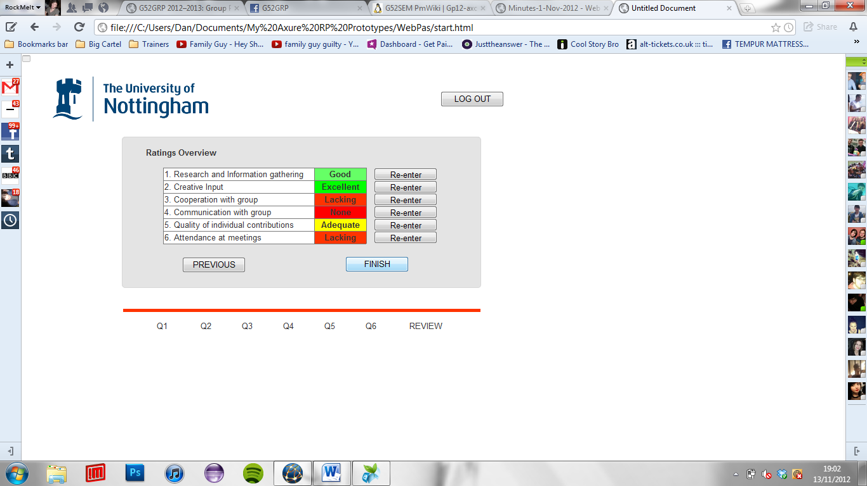

Above is the required justification screen which prompts the user to justify their ratings given, if this isn’t completed then no progress can be made, and also if the justifications aren’t adequate or believable enough then a mark may be changed afterwards in a review section with the student’s supervisor.

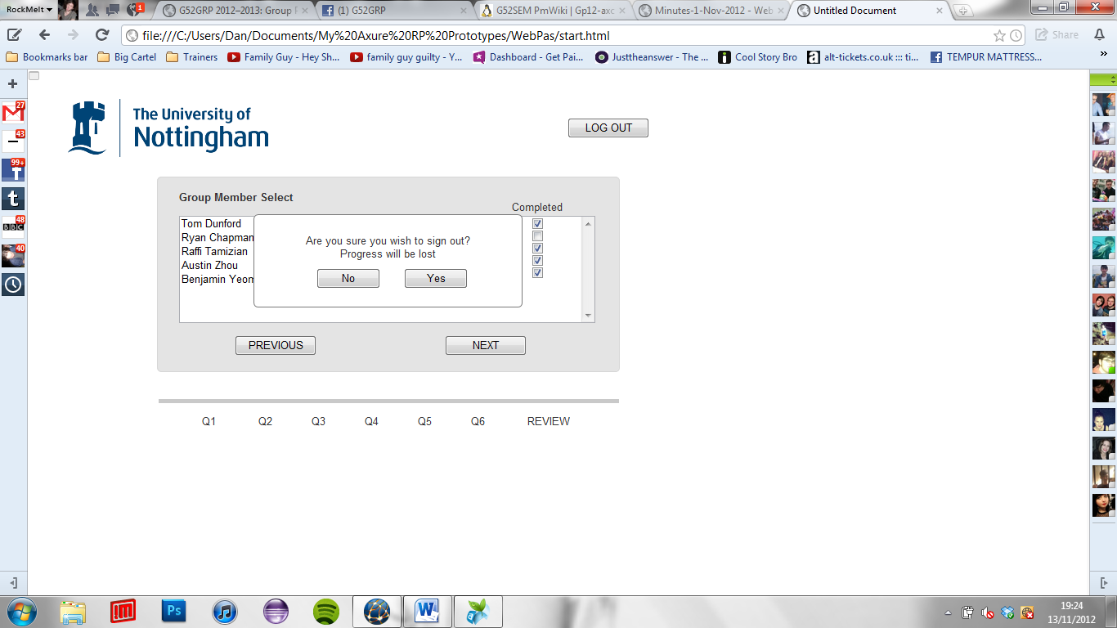

Above is the final review screen which allows for marks to be changed before they are finally submitted, this is done by simply pressing the re-enter button for the desired question. A traffic light style system is used to show what marks were given, this adds to the clarity of the review page, as you can see clearly whether you have been particularly harsh or generous is one section. Also the logout button is used throughout which when pressed would bring up the above dialogue box, because if a form isn’t fully completed marks are discarded.

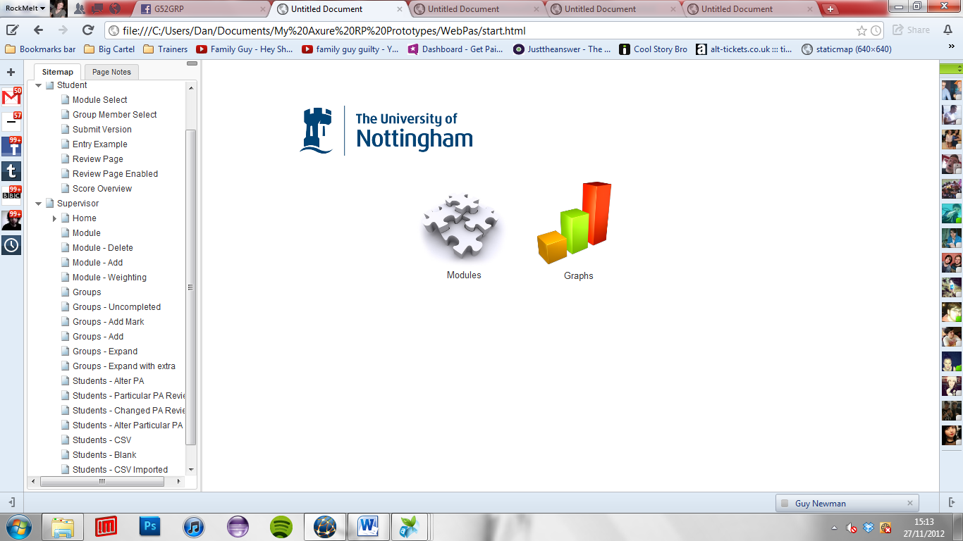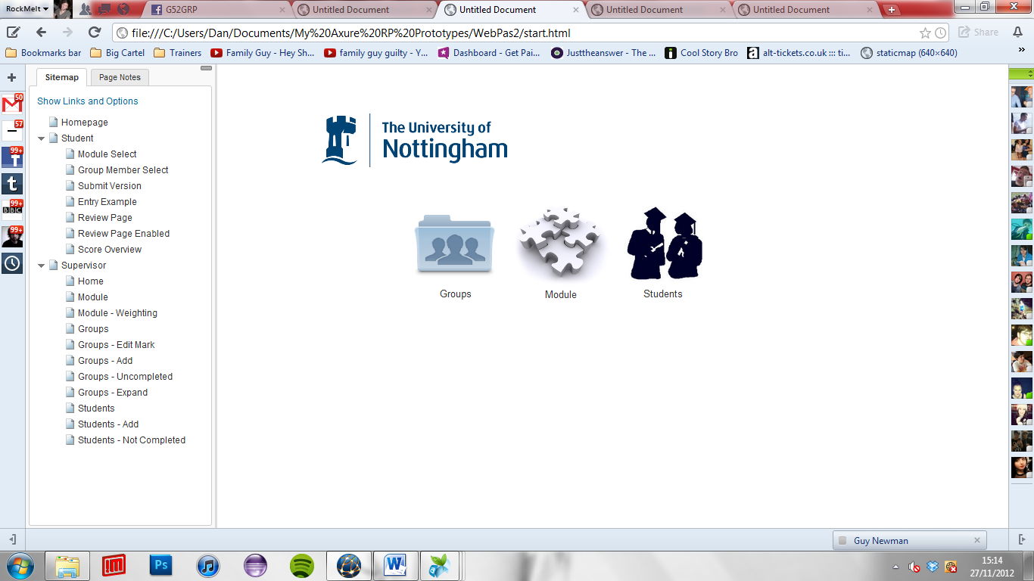CONVENOR

Iteration

Above shows one of the key iterations made from prototyping the wireframes, understanding that only modules should be accessible initially for the convenor for a peer assessment system to be a logical process, this then makes the addition of groups to modules and students to groups much easier to implement. Above shows the page the convenor will see upon entering their sign in details.

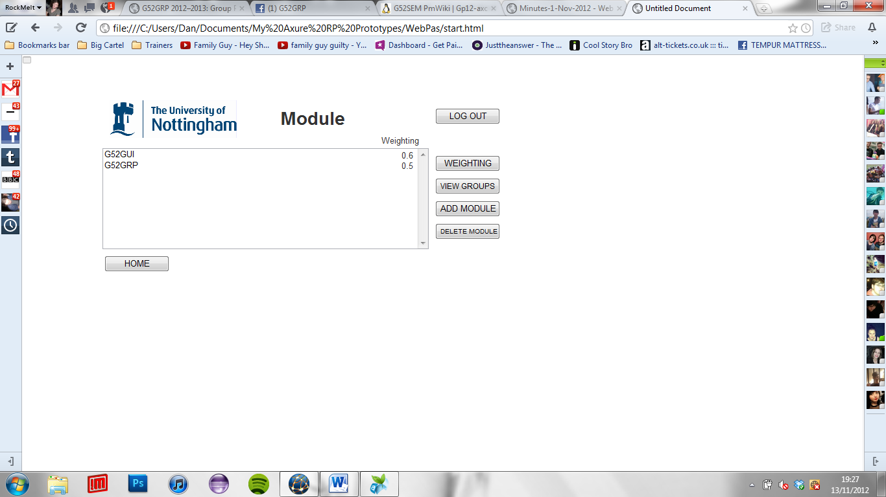

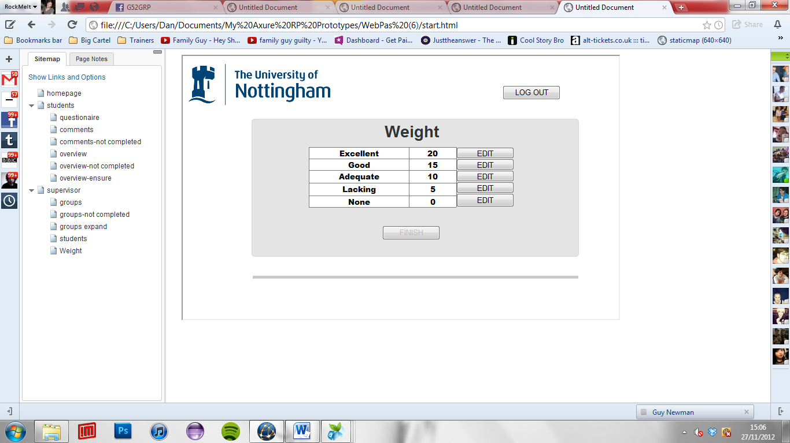

Iteration

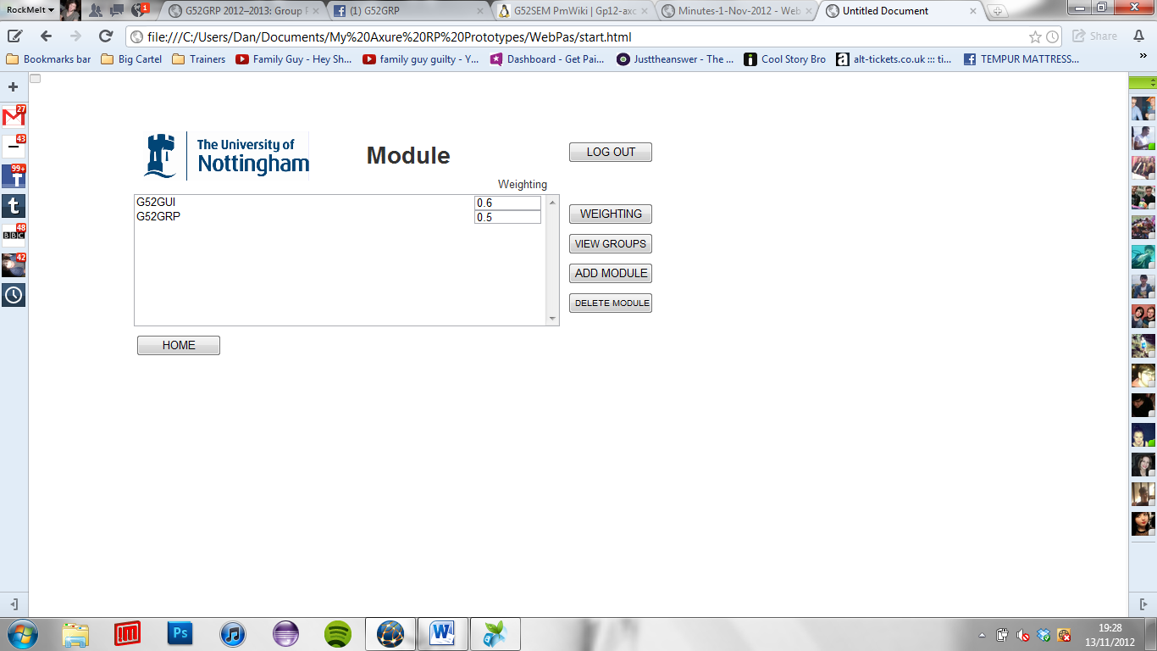

At the convenor greet screen, after sign-in, if the modules path is chosen this is the screen which will be shown, if the weighting button is pressed (as shown above) the weightings of the current modules will become editable, when pressed again it will revert. The other buttons either add a new module to the list as would be expected, and vice versa for the delete module button. When a particular module has been selected it will be highlighted, if then view groups is pressed, the groups for that module are shown. To the left shows the initial weighting screen design, which was decided against due to it adding more pages, and the decision being made that a weighting button is more user friendly and logical.

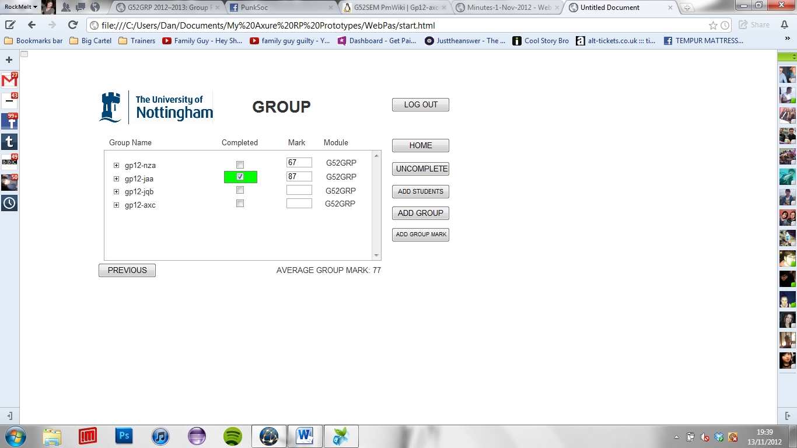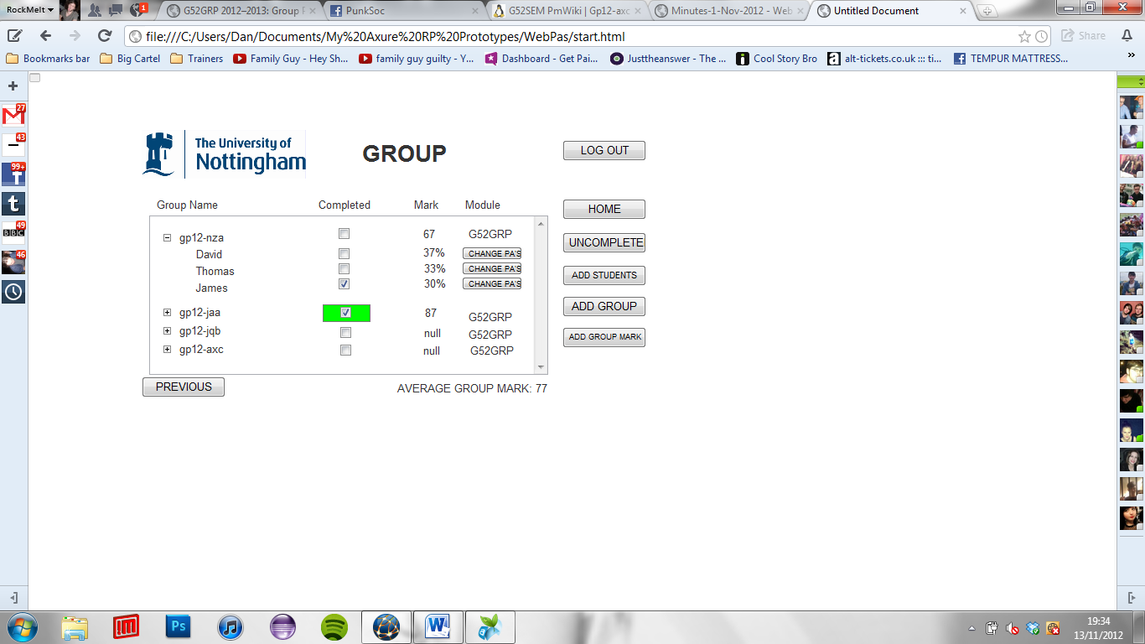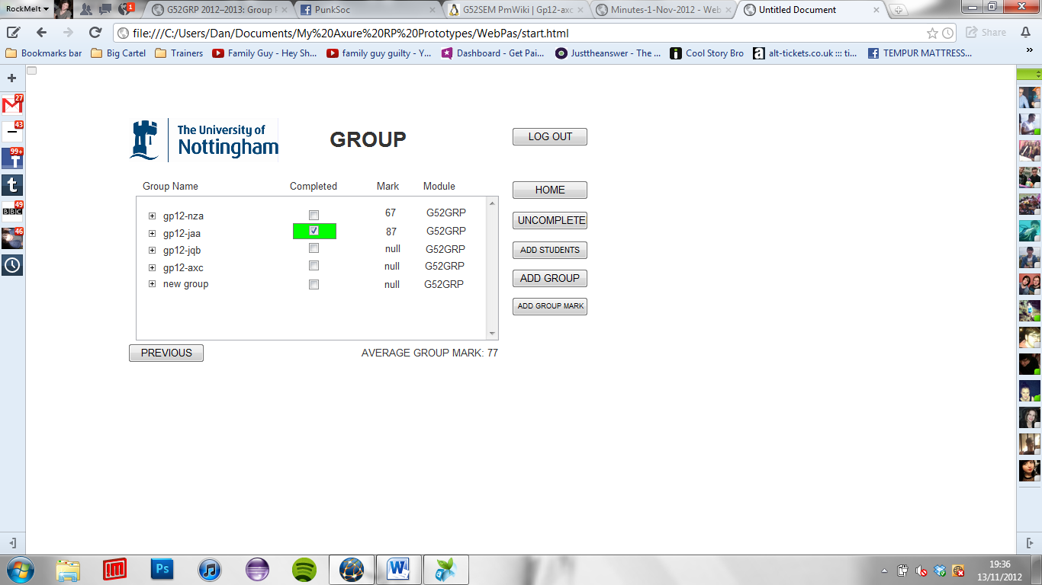

Above shows the group listing page, which is appropriate to the particular module that has been chosen for viewing. It makes use of a drop down style table, which essentially is when the group name is pressed, the members with in are shown, with the group mark split accordingly as well as the tickbox theme continued to show who has completed their PA’s. If a whole group has completed theirs then the completed field is coloured green. Some of the functionality of this page is also listed, with the add group button adding a new empty group, and the group mark button making the mark field editable. Each student within that group may have completed a set of Pa’s and as required these need to be changeable by the convener at a later date if needed. So each student’s assessments can be accessed by pressing the change Pa’s button which shows the user the below screen, with edit buttons which allows for individual editing of answers.

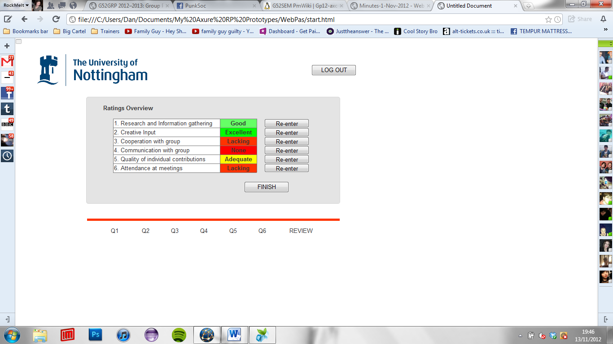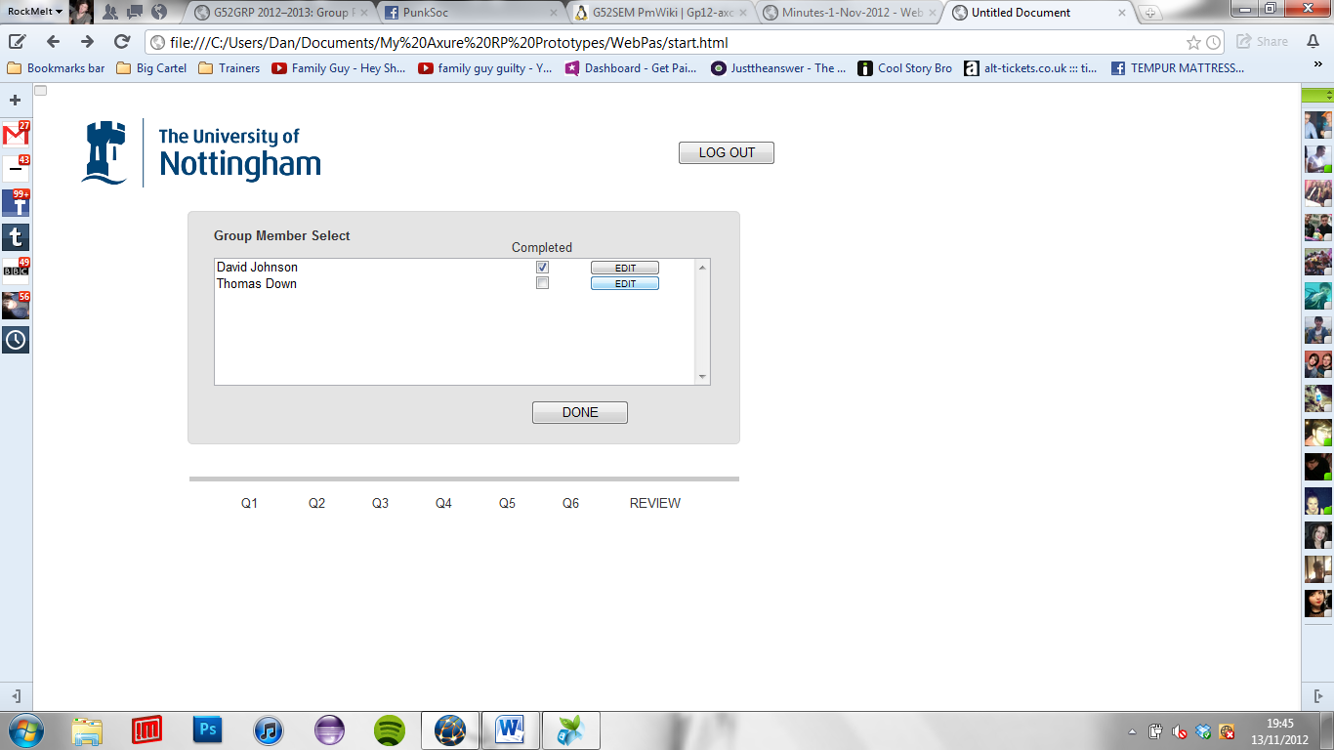

As said previously, the above shows the edit screen which only the convenor can access, with each of this particular students Pa’s being shown with edit bringing up the final review page for the peer assessment of that group member.

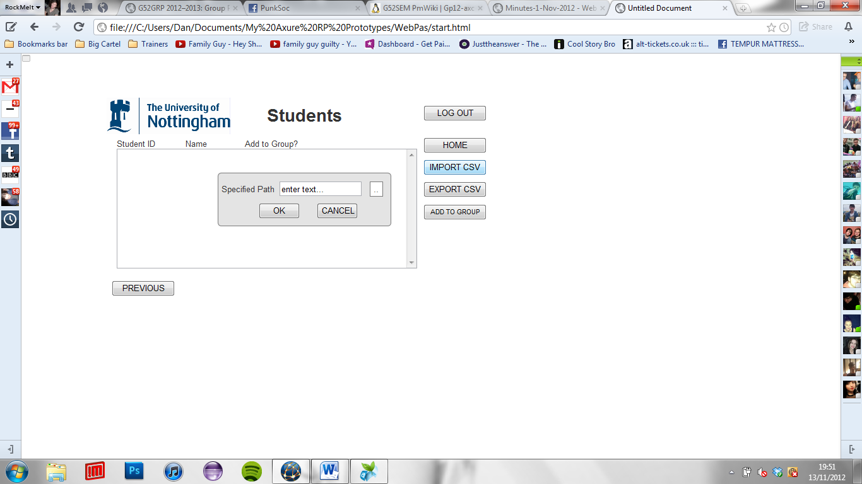

The above image shows what would display if on the previous page the add students button was pressed, this page would be shown, with an initial empty list being shown to which can be filled by importing a csv file, when “IMPORT CSV” is pressed the above dialog box would be shown, which asks for the csv’s specified path, and the usual confirm or cancel buttons being displayed afterwards. A csv file would then have to be navigated to as expected and if successful the list of students contained within it would be displayed, as shown below.

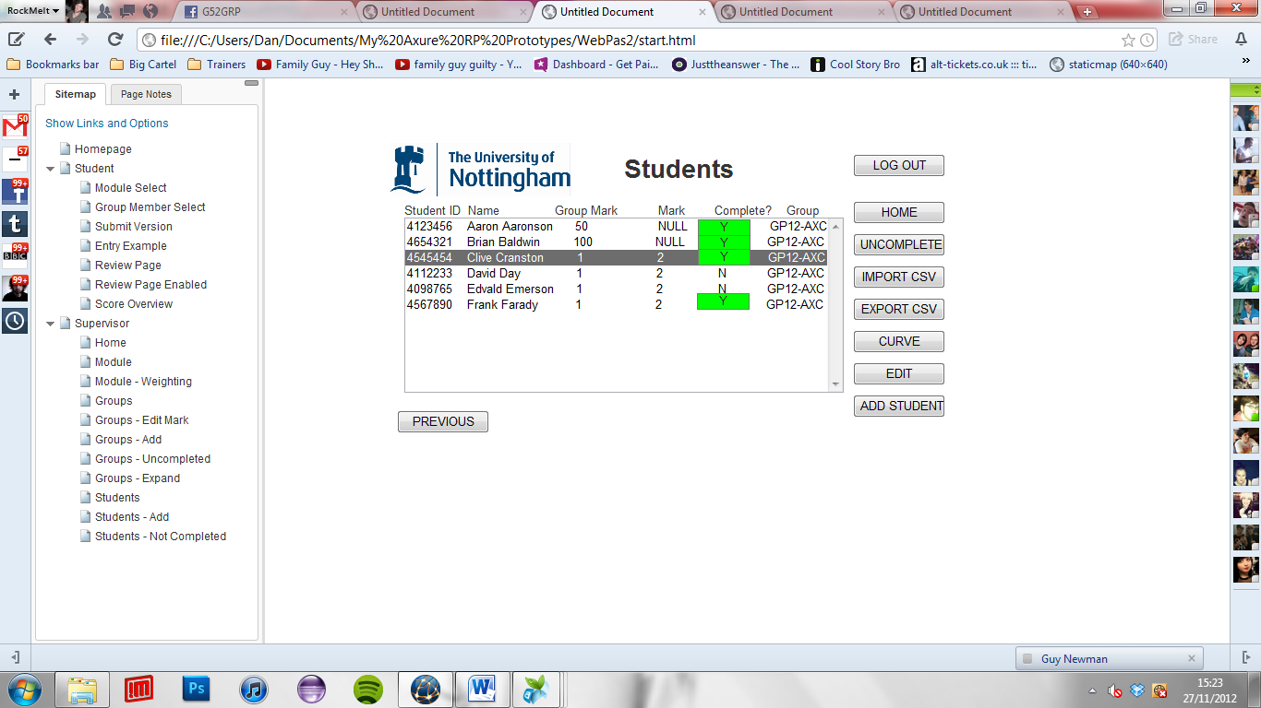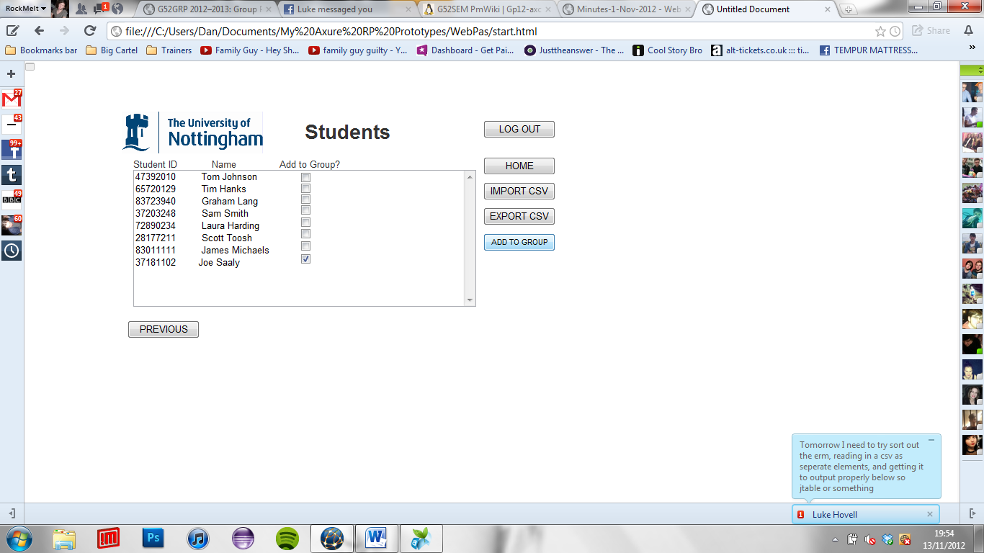

Iteration

Above shows the many changes made in result of the gradual understanding of the most logical set of steps for the user to take, i.e students only being a page for adding students to a group within a module. As a result far fewer fields are required to be shown, making the screen much simpler and easy to comprehend. In the final frame to the right, the imported list of students, and their ID’s are shown, this should be read in automatically, with a name showing only if it isn’t in a group already/or this will be prompted afterwards when adding. If a checkbox is pressed and the “add to group” button is then pressed, then that particular student/set of students will be added to the group which has been navigated through previously and the groups page will be redirected to.

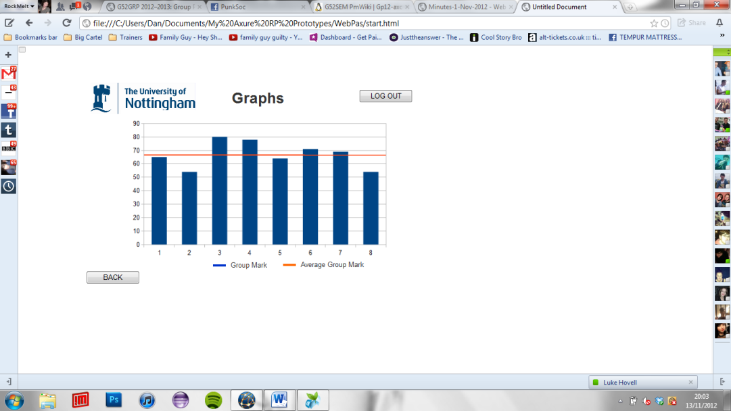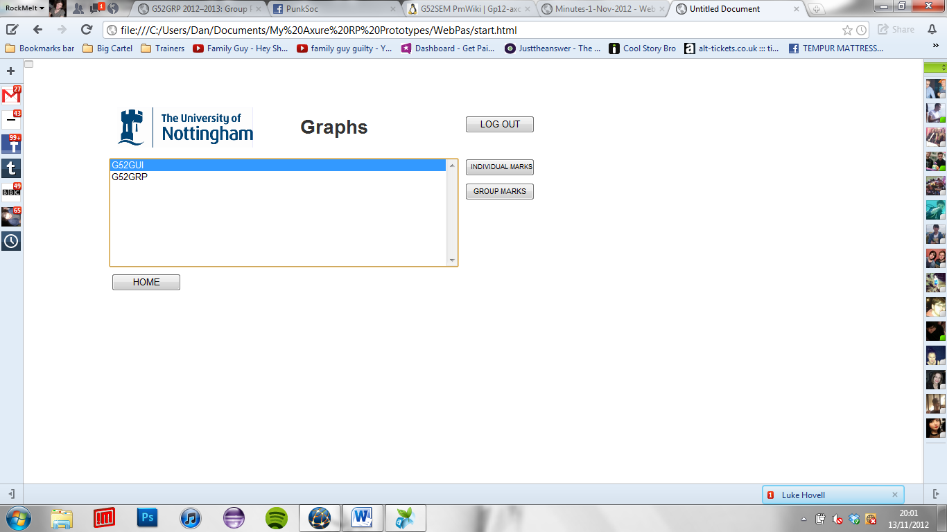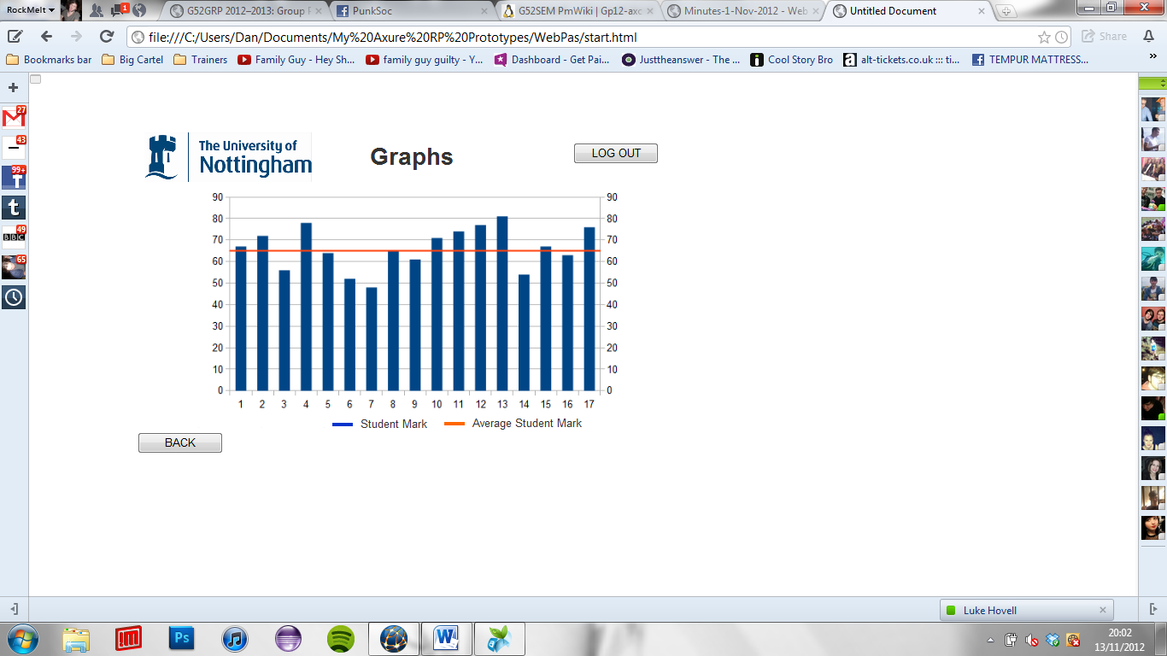

Another of the features available to a convenor upon sign-in is to view two maps for each module chosen, these will consist of either individual marks, and an average of these plotted upon a simple bar graph, and a group marks graph which again consists of an average but instead averaged out across the group marks allocated for that module. The colour scheme is continued throughout as expected. The final graphs used may vary to the above in type and content, but this is the initial design.